|  |  |  |
| --- | --- | --- |
| C:\Users\Brett\Desktop\JIM\GPSVFLogo (2).png | **WIRELESS PRO BATTERY TRACKER**  **-NO MONTHLY FEES-** |  |
|  | | |
| **PERFECT FOR…**   * Trailers * Generators * Roll-off Containers * Dumpsters * Portable Fuel Tanks * Concrete Mixers * Non-Powered Assets   **USERS INCLUDE…**   * Equipment Rental * Construction * Landscapers     ***ARA Associate Member*** | **PROTECT YOUR NON-POWERED ASSETS…** • Rugged **wireless tracking device** for non-powered assets. • **No wiring**. Operates on replaceable Li-ion batteries. • **2 or 4 daily position reports.** Two models available**.** • **Recovery Mode** launches **5 minute tracking**. • **Optional mounting brackets**. Standard or magnetic.   **Airtime Included • No Monthly Fees • No Contracts** | |
|  | |
| **ADDITIONAL FEATURES AND BENEFITS**  • **3 to 5 year battery life** under typical conditions. • Receive a variety of **alerts for important events**.  • **Zone Alerts** for entering or leaving defined areas.  • **Location History** with stops and durations.  • No software. Manage from **any PC or mobile device**.  • Integrated with **Google Maps** with Satellite and Street View.  • Library of **vehicle icons** to choose from, or upload your own.  • View **detailed history** and activity on map, or export to Excel.  • **Patented power management** for long battery life. | |

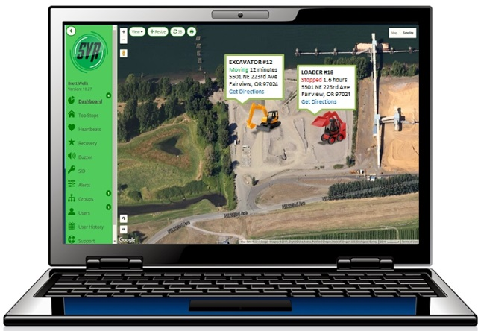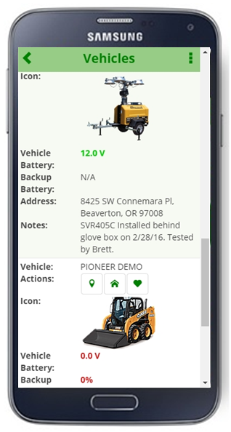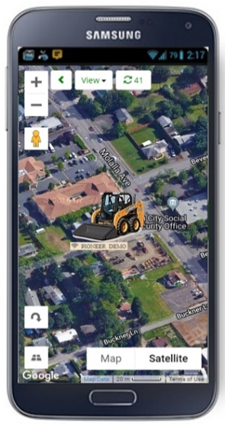C:\Users\Brett\Desktop\JIM\GPSVFLogo (2).png

**GPS Vehicle Finder • www.GpsVehicleFinder.com •** [**info@GpsVehicleFinder.com**](mailto:info@GpsVehicleFinder.com) **Jim Schumacher (888) 303-1854**

**Jim Schumacher (888) 303-1854**